**Statistical Methods for Data Science**

**Mini Project 4**

Mini Project Group No # 11

Names of group members: Parashar Parikh(pxp190016), Aakash Prajapati(axp190001)

Contribution of each group member:

Both worked on all tasks and did documentation simultaneously.

Aakash

Q1 bootstrap calculation and plot graph, Q2 and Q3 confidence interval part

Parashar

Q1 scatterplot, Q2 and Q3 normal statistics of two data sets and plotted box and histogram plots.

**Question 1.**

**1.**

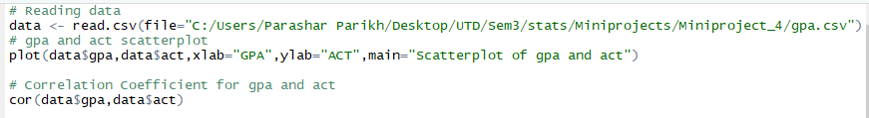

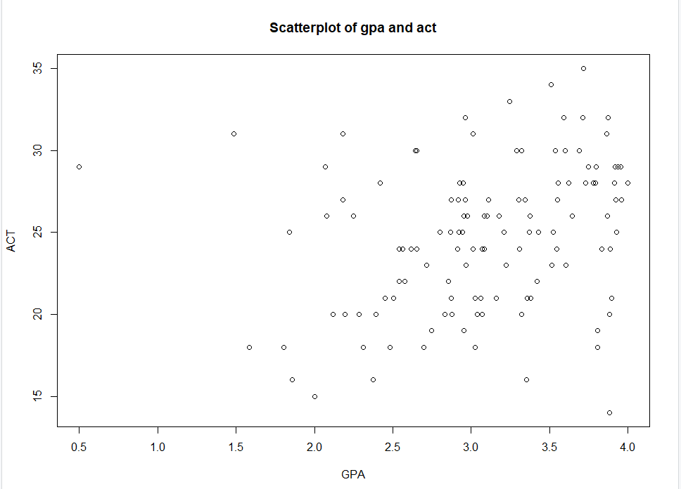

From the above scatterplot, we can observe the linear relation between student’s ACT score and GPA which is not very strong. We can see from the plot that dependency between ACT score on GPA isn’t strong because the plot is scattered. There is one more observation, increase in GPA corresponds to increase in ACT score.

**2.**



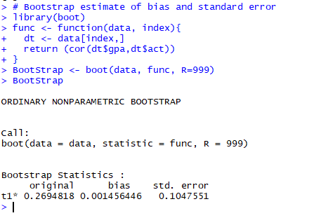



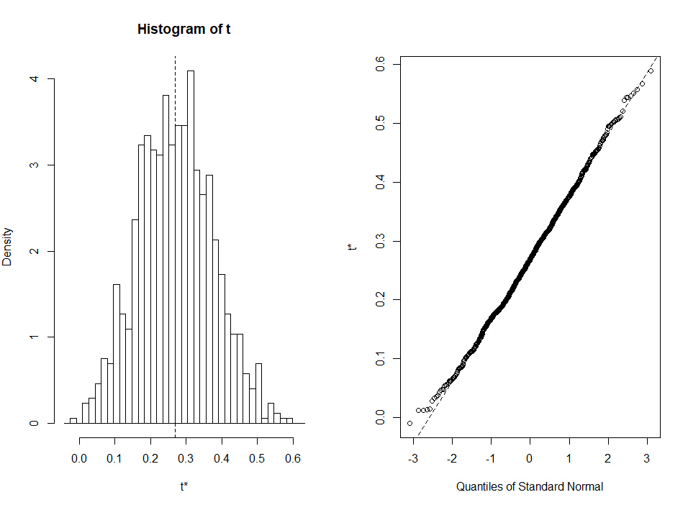

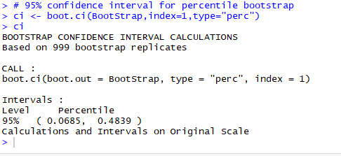

**Observations:**

From the above bootstrap estimate of bias and standard error and confidence interval plot, we can observe that the data distribution becomes normal distribution after large number of bootstrap sampling. The correlation coefficient is positive that proves that proves the positive association in initial observation and also there are some outlines in the data. We can also say that 95% confidence interval shows, that the point estimation of correlation coefficient is within the range with 0.95 probability. We can also say that the strength of relation between GPA and ACT score is strong with positive association because bootstrap confidence interval in which the correlation coefficient is, is positive apart from the outliner data.

**Question 2.**

**a.**

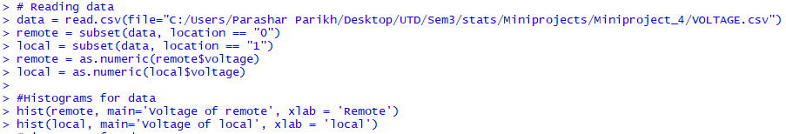

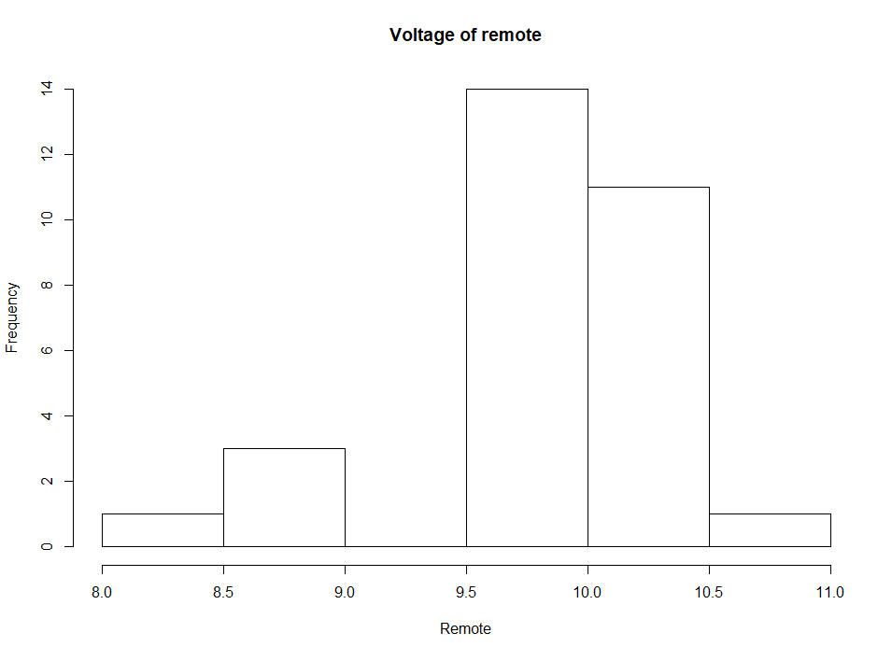

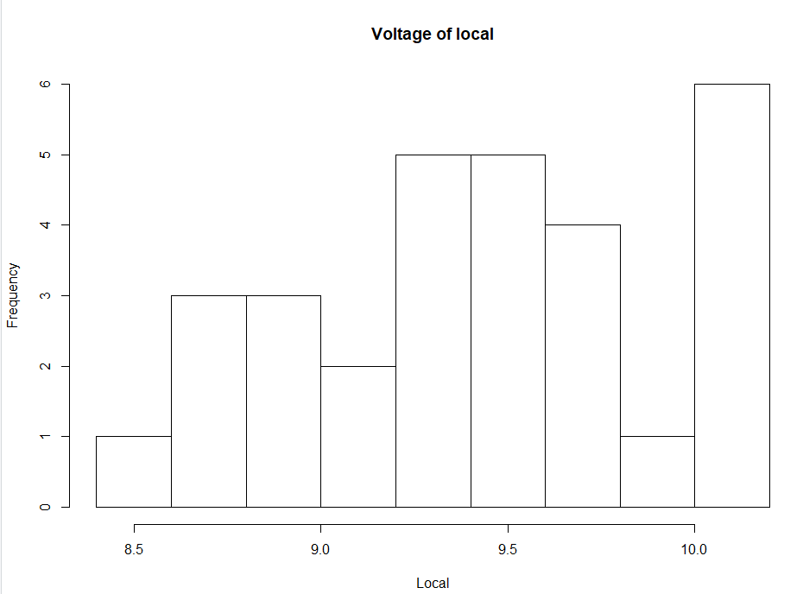



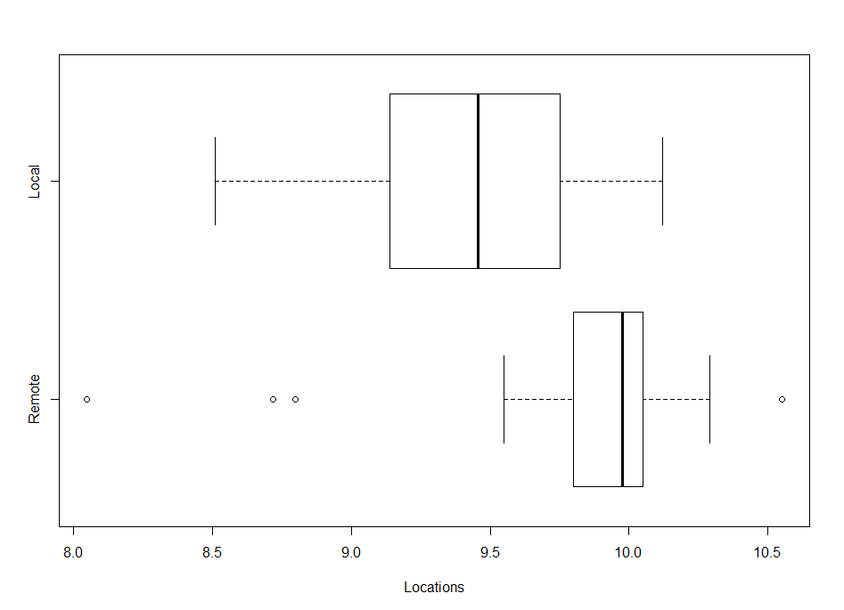

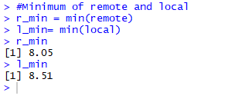

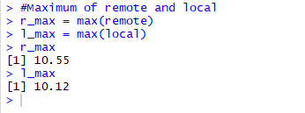

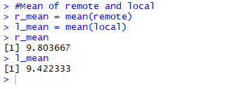

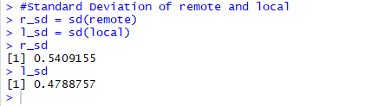

**Analysis:**

From the above, we can write the following table

|  |  |  |
| --- | --- | --- |
|  | Remote | Local |
| No of Observation | 30 | 30 |
| Minimum | 8.05 | 8.51 |
| Maximum | 10.55 | 10.12 |
| Mean | 9.8 | 9.42 |
| Standard Deviation | 0.54 | 0.48 |

**Conclusion:**

From the histogram and box plot, we can conclude that, distributions are not similar. From the above side by side box plot, we can say that distribution range of the data isn’t similar and there are many outliers. Also, from the above table for analysis, the mean is almost similar. Thus, we can conclude that the given distributions are different from each other.

**b.**



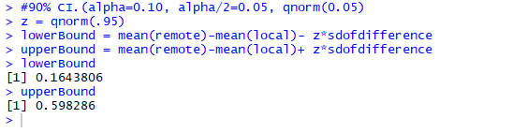

**Observations:**

We cannot manufacture locally. There is a difference in population means of voltage reading at two locations. We are getting confidence interval (0.1644, 0.5983) and 0 does not fall in this interval. Therefore, the voltage reading at local is smaller than the remote location.

**c.**

In (a) analysis we expected that the confidence interval doesn’t contain 0 and in (b) we obtained that 0 doesn’t fall in the 90% confidence interval. So, this conclude our conclusion and we can say that, the voltage reading at local is smaller than the remote location.

**2.**





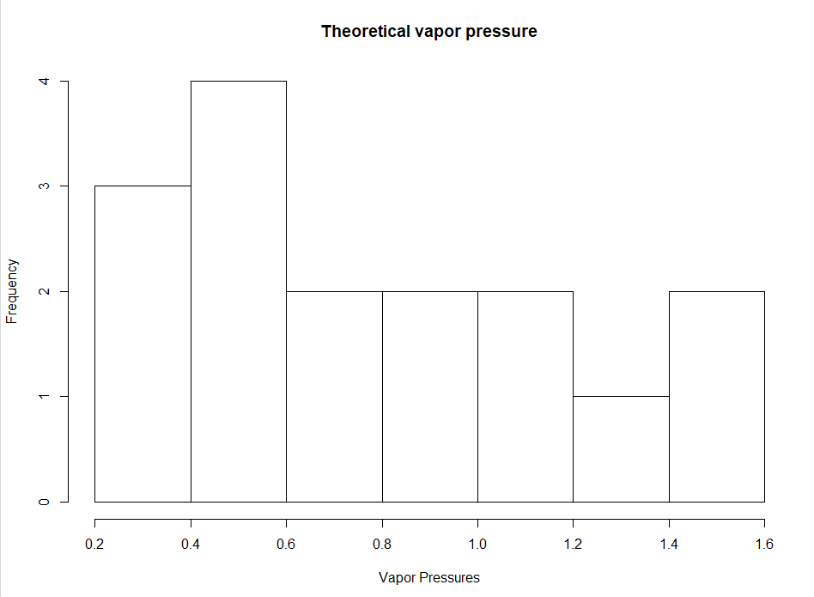

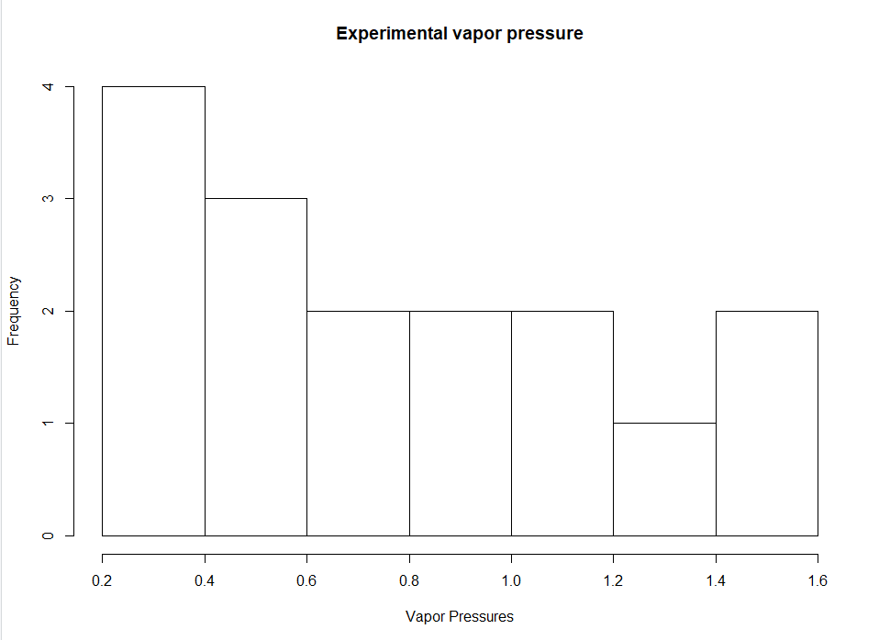



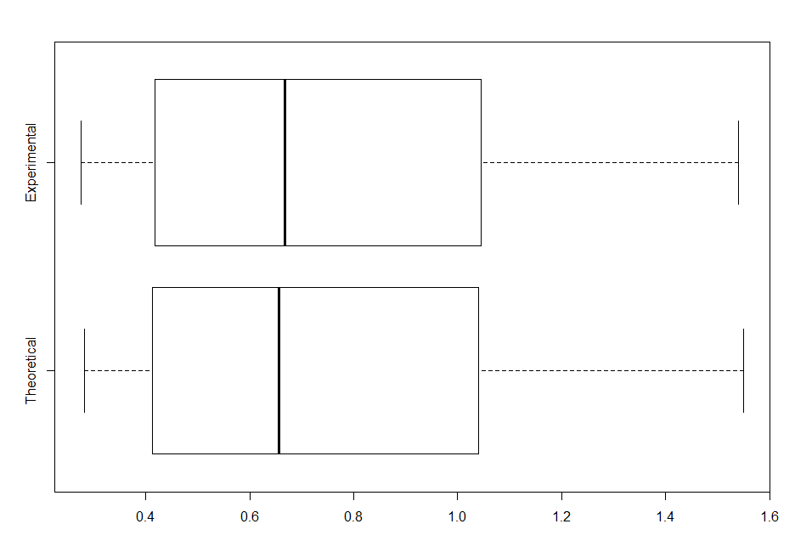

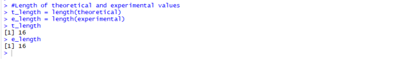

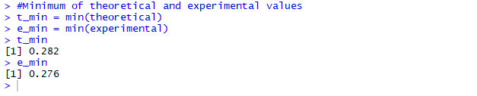

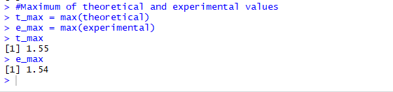

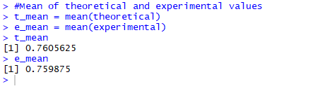

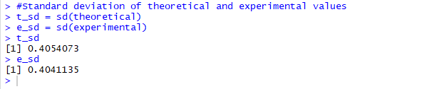

**Analysis:**

From the above, we can write the following table

|  |  |  |
| --- | --- | --- |
|  | Remote | Local |
| No of Observation | 16 | 16 |
| Minimum | 0.282 | 0.276 |
| Maximum | 1.55 | 1.54 |
| Mean | 0.760 | 0.759 |
| Standard Deviation | 0.405 | 0.405 |



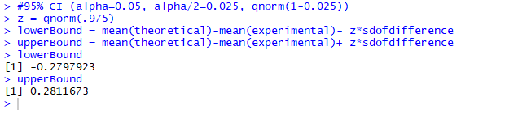

**Observations:**

From both the graphs, histogram and side by side boxplot we can say that theoretical and experimental values are same because distribution are identical.

We calculated the 95% confidence interval and 0 falls in the interval. So, we can conclude that for the large number of samples mean difference between both values (theoretical and experimental) will be almost 0.

**Conclusion:**

From the above two observations we can conclude that the statement is true that, the theoretical model of vapor pressure is a good model of reality.

**Source code:**

# Reading data

data<-read.csv(file="C:/Users/Parashar Parikh/Desktop/UTD/Sem3/stats/Miniprojects/Miniproject_4/gpa.csv")

# gpa and act scatterplot

plot(data$gpa,data$act,xlab="GPA",ylab="ACT",main="Scatterplot of gpa and act")

# Correlation Coefficient for gpa and act

cor(data$gpa,data$act)

# Bootstrap estimate of bias and standard error

library(boot)

func <- function(data, index){

dt <- data[index,]

return (cor(dt$gpa,dt$act))

}

BootStrap <- boot(data, func, R=999)

BootStrap

#Plotting bootstrap estimation

plot(BootStrap)

# 95% confidence interval for percentile bootstrap

ci <- boot.ci(BootStrap,index=1,type="perc")

ci

# Reading data

data = read.csv(file="C:/Users/Parashar Parikh/Desktop/UTD/Sem3/stats/Miniprojects/Miniproject_4/VOLTAGE.csv")

remote = subset(data, location == "0")

local = subset(data, location == "1")

remote = as.numeric(remote$voltage)

local = as.numeric(local$voltage)

#Histograms for data

hist(remote, main='Voltage of remote', xlab = 'Remote')

hist(local, main='Voltage of local', xlab = 'Local')

#Side by side boxplot of Remote and local locations

boxplot(remote,local,horizontal=TRUE,names=c("Remote","Local"),xlab="Locations")

#Length of remote and local

r_length = length(remote)

l_length = length(local)

#Minimum of remote and local

r_min = min(remote)

l_min= min(local)

r_min

l_min

#Maximum of remote and local

r_max = max(remote)

l_max = max(local)

r_max

l_max

#Mean of remote and local

r_mean = mean(remote)

l_mean = mean(local)

r_mean

l_mean

#Standard Deviation of remote and local

r_sd = sd(remote)

l_sd = sd(local)

r_sd

l_sd

sdofdifference = sqrt( (sd(remote)**2/length(remote)) + (sd(local)**2/length(local)) )

sdofdifference

#90% CI.(alpha=0.10, alpha/2=0.05, qnorm(1-0.05)

z = qnorm(.95)

lowerBound = mean(remote)-mean(local)- z*sdofdifference

upperBound = mean(remote)-mean(local)+ z*sdofdifference

lowerBound

upperBound

# Read the data from csv

data = read.csv('C:/Users/Parashar Parikh/Desktop/UTD/Sem3/stats/Miniprojects/Miniproject_4/VAPOR.csv')

theoretical = as.numeric(data$theoretical)

experimental = as.numeric(data$experimental)

#Length of theoretical and experimental values

t_length = length(theoretical)

e_length = length(experimental)

t_length

e_length

#Minimum of theoretical and experimental values

t_min = min(theoretical)

e_min = min(experimental)

t_min

e_min

#Maximum of theoretical and experimental values

t_max = max(theoretical)

e_max = max(experimental)

t_max

e_max

#Mean of theoretical and experimental values

t_mean = mean(theoretical)

e_mean = mean(experimental)

t_mean

e_mean

#Standard deviation of theoretical and experimental values

t_sd = sd(theoretical)

e_sd = sd(experimental)

t_sd

e_sd

#Histogram of theoretical and experimental values

hist(theoretical, main='Theoretical vapor pressure', xlab='Vapor Pressures')

hist(experimental, main='Experimental vapor pressure', xlab='Vapor Pressures')

#Side by side boxplot of theoretical and experimental values

boxplot(theoretical, experimental,horizontal=TRUE,names=c("Theoretical","Experimental"))

sdofdifference = sqrt( ((t_sd**2)/length(theoretical)) + ((e_sd**2)/length(experimental)) )

#95% CI (alpha=0.05, alpha/2=0.025, qnorm(1-0.025))

z = qnorm(.975)

lowerBound = mean(theoretical)-mean(experimental)- z*sdofdifference

upperBound = mean(theoretical)-mean(experimental)+ z*sdofdifference

lowerBound

upperBound